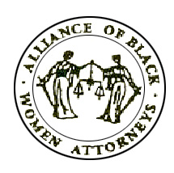
ALLIANCE OF BLACK WOMEN ATTORNEYS OF MARYLAND, INC.
www.abwamaryland.org

MEMBERSHIP APPLICATION
2018-2019

New Member ____ Renewal_____ Subscribe to Listserv_____

NAME_________________________________________________________________

HOME ADDRESS____________________________________________________________________

____________________________________________________________________

HOME PHONE_____________________________ WORK PHONE_______________________

EMPLOYER________________________________________________________________________

EMPLOYER ADDRESS ______________________________________________________________

______________________________________________________________

EMAIL ADDRESS ___________________________________________________________________

AREA(S) OF SPECIALTY_____________________________________________________________

STATE BAR MEMBERSHIP(S) ________________________________________________________

LAW SCHOOL ______________________________________________________________________

DUES CATEGORIES: (Select one)

MEMBERSHIP

____ $50.00 (Graduated more than 5 years ago)

____ $40.00 (Graduated 3-5 years ago)

____ $30.00 (Graduated less than 3 years ago)

____ Free (Law Student)

COMMITTEES OF INTEREST:
___ Membership ___ Finance ___ Judicial Selection ___ Website ___ History ___ Events ___ Community Service

METHOD OF PAYMENT: ___Cash ___PayPal ___Check

Please Make Check Payable and Mail To:

Alliance of Black Women Attorneys of Maryland
Attn: Membership
P.O. Box 23784
Baltimore, MD 21203

